HTML 5 INTRODUCTION

* HTML (Hypertext Markup Language) is the standard language used for creating web pages on the World Wide Web.
* It provides a structured format for organizing and presenting content on the internet.
* HTML uses a set of tags to define elements such as headings, paragraphs, lists, tables, forms, and media.
* Tags are enclosed in angle brackets ("<" and ">") and are paired as opening and closing tags.
* HTML allows for the inclusion of images, videos, audio files, and other media types.
* It supports the use of Cascading Style Sheets (CSS) to control the visual appearance of web pages.
* HTML can be viewed on various devices, including desktop computers, laptops, tablets, and smartphones.
* Web browsers interpret HTML documents and render them into visual web pages.
* HTML provides the necessary structure and semantics for accessibility and compatibility across different browsing environments.
* It is a foundational skill for web developers and designers, as it forms the basis for creating interactive and dynamic web pages.
* HTML has evolved over time with different versions, with each version introducing new features and improvements.
* Learning HTML is essential for anyone involved in creating web pages, websites, or web applications.



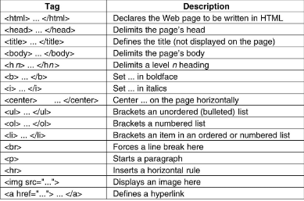

Certainly! I can provide you with a simple HTML example and explain each part of it. Here's an example of a basic HTML document structure:

* 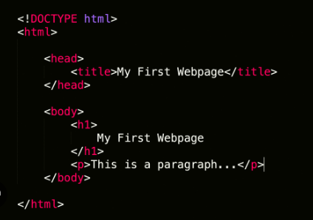
* Let's break it down:
* <!DOCTYPE html>: This is the document type declaration and it informs the browser that the document is an HTML5 document.
* <html>: The <html> element serves as the root element of an HTML document.
* <head>: The <head> element is a container for metadata and other head elements, such as the page title.
* <title>: The <title> element sets the title of the HTML document, which appears in the browser's title bar or tab.
* <body>: The <body> element contains the visible content of the HTML document, such as text, images, links, and other elements.
* <h1>: The <h1> element represents a heading and is the highest level of heading in HTML.
* <p>: *The* <p> element represents a paragraph of text.
* When you open this HTML document in a web browser, it will display a page with the following content:
* Title: My First HTML Page
* Body:
* Heading: Welcome to My Page
* Paragraph: This is a paragraph of text.
* This is a basic example to demonstrate the structure of an HTML document. In real-world scenarios, you can add many more elements, attributes, and styles to create complex web pages. HTML is a markup language that allows you to structure the content and define its presentation on the web.
* Top of Form

HTML Element with Example

* HTML elements are the building blocks of web pages. They define the structure and content of a document.
* HTML elements are represented by tags enclosed in angle brackets (**<>**). They typically come in pairs: an opening tag and a closing tag.
* Opening tags indicate the start of an element, and closing tags indicate the end. For self-closing elements (e.g., **<br>**), the closing tag is omitted.
* Elements can contain other elements, creating a hierarchical structure.
* Each element can have attributes, which provide additional information about the element. Attributes are specified within the opening tag.
* HTML documents typically have a root element, **<html>**, which contains all other elements.
* Common elements include headings (**<h1>** to **<h6>**), paragraphs (**<p>**), links (**<a>**), images (**<img>**), lists (**<ul>**, **<ol>**, **<li>**), tables (**<table>**, **<tr>**, **<td>**), and forms (**<form>**, **<input>**, **<button>**).
* Elements can be styled using CSS (Cascading Style Sheets) to control their appearance, layout, and behavior.
* HTML provides semantic elements that give meaning to the structure of a web page, such as **<header>**, **<nav>**, **<section>**, **<article>**, **<footer>**, etc.
* New HTML elements are periodically introduced, enhancing the capabilities and expressiveness of web documents. It's important to stay updated with the latest HTML specifications.
* Remember that this is just a brief overview of HTML elements. HTML is a powerful language that allows you to create rich and interactive web pages by combining different elements, attributes, and styles.
* Top of Form

HTML Attributes

* Bottom of Form
* Top of Form
* HTML elements are the building blocks of web pages. They define the structure and content of a document.
* HTML elements are represented by tags enclosed in angle brackets (**<>**). They typically come in pairs: an opening tag and a closing tag.
* Opening tags indicate the start of an element, and closing tags indicate the end. For self-closing elements (e.g., **<br>**), the closing tag is omitted.
* Elements can contain other elements, creating a hierarchical structure.
* Each element can have attributes, which provide additional information about the element. Attributes are specified within the opening tag.
* HTML documents typically have a root element, **<html>**, which contains all other elements.
* Common elements include headings (**<h1>** to **<h6>**), paragraphs (**<p>**), links (**<a>**), images (**<img>**), lists (**<ul>**, **<ol>**, **<li>**), tables (**<table>**, **<tr>**, **<td>**), and forms (**<form>**, **<input>**, **<button>**).
* Elements can be styled using CSS (Cascading Style Sheets) to control their appearance, layout, and behavior.
* HTML provides semantic elements that give meaning to the structure of a web page, such as **<header>**, **<nav>**, **<section>**, **<article>**, **<footer>**, etc.
* New HTML elements are periodically introduced, enhancing the capabilities and expressiveness of web documents. It's important to stay updated with the latest HTML specifications.
* Remember that this is just a brief overview of HTML elements. HTML is a powerful language that allows you to create rich and interactive web pages by combining different elements, attributes, and styles.
* html attributes
* HTML attributes provide additional information about an HTML element. They are used to modify the behavior or appearance of an element. Here are some key points about HTML attributes:
* Attributes are added within the opening tag of an HTML element and are specified as name-value pairs, separated by an equals sign (**=**).
* The name of the attribute describes the type of information it represents, such as **src** for specifying the source of an image or **href** for specifying the destination of a link.
* The value of the attribute provides the actual information or setting for the attribute. It is enclosed in quotes, either single (**'**) or double (**"**), although quotes are not always required for certain attribute values.
* Some attributes don't require a value and are simply used to enable or disable a particular behavior. In such cases, the attribute name alone is sufficient.
* Elements can have multiple attributes, each separated by a space within the opening tag.
* Common attributes include:
* class: Specifies one or more CSS classes to apply to an element for styling or targeting with CSS or JavaScript.
* id: Assigns a unique identifier to an element, allowing it to be targeted specifically with CSS or JavaScript.
* style: Defines inline CSS styles to apply directly to an element.
* src: Specifies the source URL of an external resource, such as an image, script, or video.
* href: Sets the URL destination for links or anchors.
* alt: Provides alternative text for images, which is displayed when the image cannot be loaded or for accessibility purposes.
* disabled: Disables an input element or button.
* required: Indicates that an input field must be filled out before submitting a form.
* Custom attributes can also be used to store data or provide additional functionality, but they should follow the format **data-** followed by a descriptive name (e.g., **data-custom**).
* Different elements support different attributes, so it's important to refer to the documentation or specifications for specific elements to know which attributes are applicable.
* Attributes play a vital role in HTML, allowing developers to control and customize the behavior and appearance of elements. They are a fundamental part of building dynamic and interactive web pages.
* 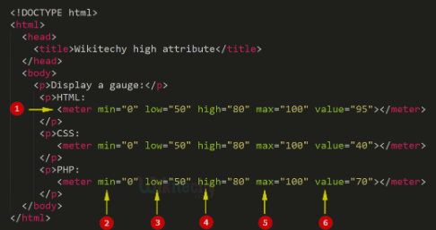
* Top of Form

HTML comments

* HTML comments are enclosed between **<!--** and **-->**.
* Comments can span multiple lines or be a single line.
* Comments can be placed anywhere within the HTML code, including between elements, within an element, or at the beginning or end of the document.
* HTML comments are primarily used for documentation, clarification, or temporarily disabling code without removing it entirely.
* Comments are useful for making the code more readable and understandable, especially for other developers who may be working on the same project.
* Comments can be used to provide instructions or explanations for specific sections of code, describe the purpose of an element or attribute, or note areas that need attention or improvement.
* It is considered good practice to use comments to explain complex or non-obvious parts of the code, outline the structure of the document, or provide details about the author, date, or version of the HTML file.
* It's important to note that HTML comments are visible when inspecting the

HTML style

Top of Form

<!DOCTYPE html>

<html>

<head>

<style>

/* CSS rules for text styling */

.red-text {

color: red;

}

.bold-text {

font-weight: bold;

}

.italic-text {

font-style: italic;

}

.underline-text {

text-decoration: underline;

}

.highlight-text {

background-color: yellow;

}

</style>

</head>

<body>

<p class="red-text">This text is red.</p>

<p class="bold-text">This text is bold.</p>

<p class="italic-text">This text is italic.</p>

<p class="underline-text">This text is underlined.</p>

<p class="highlight-text">This text is highlighted.</p>

</body>

</html>

Html colors-

* In HTML, colors can be specified using various formats. Here are the commonly used ways to define colors in HTML:
* Named Colors: HTML supports a set of predefined color names such as "red", "blue", "green", etc. These names can be used directly as attribute values or within CSS styles. For example:
* <p style="color: red;">This text is red.</p>
* Hexadecimal Notation: Colors can be represented using a six-digit hexadecimal value that combines red, green, and blue (RGB) values. Each pair of digits represents the intensity of each color component. For example:
* <p style="color: #FF0000;">This text is red.</p>
* Short Hexadecimal Notation: You can use a three-digit hexadecimal value to represent colors if each component's intensity is the same. For example, "#F00" is equivalent to "#FF0000" (red).
* RGB Values: Colors can be defined using RGB values, where the intensity of red, green, and blue is specified using decimal values between 0 and 255. For example:

<p style="color: rgb(255, 0, 0);">This text is red.</p>

* RGBA Values: Similar to RGB, RGBA values allow you to specify an additional alpha channel representing the opacity of the color. The alpha value ranges from 0 (completely transparent) to 1 (fully opaque). For example:
* <p style="color: rgba(255, 0, 0, 0.5);">This text is semi-transparent red.</p>

HSL and HSLA Values: HSL (Hue, Saturation, Lightness) is an alternative color model where colors are defined using hue values (0 to 360 degrees), saturation values (0% to 100%), and lightness values (0% to 100%). HSLA is similar to HSL but includes an alpha channel for opacity. For example:

* <p style="color: hsl(0, 100%, 50%);">This text is a bright red.</p>
* CSS styles can be applied using the **style** attribute within HTML tags, or by using external CSS files and referencing the appropriate class or ID selectors.
* Note that colors can also be used for backgrounds, borders, and other styling properties in addition to text color.
* 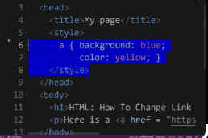
* Top of Form

Html section

The **<section>** element is a semantic element introduced in HTML5 to provide a clearer structure to web documents.

* It is intended to be used for grouping related content together, such as chapters, articles, or different parts of a webpage.
* A **<section>** element typically contains a heading to provide a descriptive title for the section. The heading can be represented using **<h1>** to **<h6>** tags.
* Multiple **<section>** elements can be used within a document to organize content hierarchically. Each **<section>** can have its own heading.
* The content inside a **<section>** can include any valid HTML elements, such as paragraphs, images, lists, tables, and other nested sections.
* The purpose of using the **<section>** element is to convey the structure and meaning of the content to assistive technologies, search engines, and developers.
* Here's an example that demonstrates the usage of the **<section>** element:

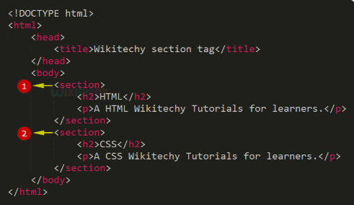

* Top of Form

<!DOCTYPE html>

<html>

<head>

<title>My Web Page</title>

</head>

<body>

<header>

<h1>Welcome to My Web Page</h1>

</header>

<nav>

<!-- navigation menu goes here -->

</nav>

<section>

<h2>About Me</h2>

<p>Some information about myself.</p>

</section>

<section>

<h2>My Skills</h2>

<ul>

<li>HTML</li>

<li>CSS</li>

<li>JavaScript</li>

</ul>

</section>

<section>

Html centered-

* To center elements in HTML, you can use various methods depending on the context and the type of element you want to center. Here are some points on how to center elements in HTML:
* To center elements in HTML, you can use various methods depending on the context and the type of element you want to center. Here are some points on how to center elements in HTML:

Centering Text:

* To center text horizontally, you can use the CSS **text-align** property and set its value to **center** on the containing element, such as a **<div>** or a **<p>** tag.
* Example: **<div style="text-align: center;">Centered Text</div>**

Centering Block-Level Elements:

* To center a block-level element (like a **<div>**, **<section>**, or **<ul>**), you can use CSS with the following properties:
* **margin-left: auto;**
* **margin-right: auto;**
* Example: **<div style="margin-left: auto; margin-right: auto; width: 50%;">Centered Block</div>**

Centering Images:

* To center an image horizontally, you can use the same CSS properties as for block-level elements.
* Example: **<img src="image.jpg" style="display: block; margin-left: auto; margin-right: auto;">**
* Centering Tables:
* To center a table horizontally, you can wrap it in a **<div>** element and apply the same CSS properties for centering block-level elements.
* Example: **<div style="margin-left: auto; margin-right: auto;"><table>...</table></div>**
* Centering Flexbox or Grid Items:
* If you are using CSS Flexbox or Grid, you can use the appropriate alignment properties to center items horizontally and vertically.
* Example (Flexbox): **<div style="display: flex; justify-content: center; align-items: center;">Centered Content</div>**
* Remember to adjust the CSS properties and values based on your specific requirements and the structure of your HTML elements.
* Top of Form
* HTML Basic Example-
* 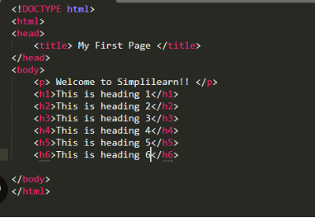
* Certainly! Here are some basic concepts of HTML (Hypertext Markup Language):
* Structure: HTML provides the structure for creating web pages. It consists of a collection of elements that define the different parts of a page.
* Tags: HTML uses tags to define elements. Tags are enclosed in angle brackets (< >) and come in pairs: opening and closing tags. Opening tags denote the start of an element, and closing tags denote the end. For example, **<h1>** is an opening tag for a heading element, and **</h1>** is the corresponding closing tag.
* Elements: HTML elements represent different parts of a web page's content, such as headings, paragraphs, images, links, lists, forms, and more. Each element has a specific purpose and semantic meaning. Elements are defined using tags.
* Top of Form

HTML Heading tag

<!DOCTYPE html>

<html>

<head>

<title>Heading Tags Example</title>

</head>

<body>

<h1>Main Heading</h1>

<h2>Subheading</h2>

<h3>Subheading</h3>

<h4>Subheading</h4>

<h5>Subheading</h5>

<h6>Subheading</h6>

</body>

</html>

Html paragraphs

<!DOCTYPE html>

<html>

<head>

<title>Paragraph Example</title>

</head>

<body>

<p>This is the first paragraph.</p>

<p>This is the second paragraph.</p>

<p>This is the third paragraph.</p>

</body>

</html>

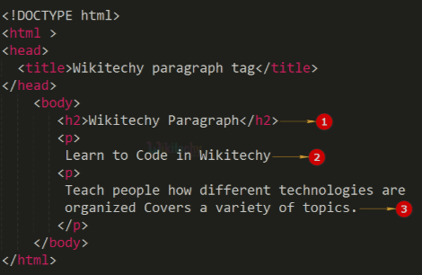

* In HTML, paragraphs are represented by the **<p>** element. The **<p>** element is used to define a block of text or a paragraph within an HTML document. Here's an example of how to use paragraphs in HTML:
* In the example above, three paragraphs are created using the **<p>** element. Each paragraph is enclosed in opening and closing **<p>** tags. The text within the **<p>** tags represents the content of the paragraphs.
* Paragraphs are block-level elements, which means they typically appear on a new line and have some spacing around them by default. CSS can be used to modify the appearance of paragraphs, such as changing the font, color, or adding margins and padding.
* Remember to use paragraphs appropriately to structure and organize your content, making it more readable and visually appealing for users.

Top of Form

Html 5 links-

* In HTML5, links are created using the <a> (anchor) element. Links allow users to navigate between web pages, sections within a page, or external resources. Here's an example of how to create links in HTML5:

html

Copy code

<!DOCTYPE html>

<html>

<head>

<title>Link Example</title>

</head>

<body>

<h1>Link Example</h1>

<p>This is a link to another webpage: <a href="https://www.example.com">Example Website</a>.</p>

<p>This is a link to a section within the same page: <a href="#section2">Go to Section 2</a>.</p>

<h2 id="section2">Section 2</h2>

<p>This is the content of Section 2.</p>

</body>

</html>

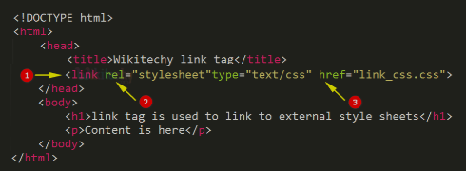

In this example:

<!DOCTYPE html>

<html>

<head>

<title>Link Example</title>

</head>

<body>

<h1>Link Example</h1>

<p>This is a link to another webpage: <a href="https://www.example.com">Example Website</a>.</p>

<p>This is a link to a section within the same page: <a href="#section2">Go to Section 2</a>.</p>

<h2 id="section2">Section 2</h2>

<p>This is the content of Section 2.</p>

</body>

</html>

* The first link is an example of an external link. The <a> element uses the href attribute to specify the URL of the target page (in this case, "https://www.example.com"). The link text "Example Website" is displayed to the user, and clicking on it will navigate to the specified URL.
* The second link demonstrates an internal link. The href attribute value starts with a hash symbol (#) followed by the id attribute of the target element. In this case, the link points to the section with id="section2". Clicking on the link will scroll the page to the corresponding section.
* Remember to provide meaningful and descriptive link text to improve accessibility and user experience. Additionally, you can use various attributes and techniques in HTML5, such as target to open the link in a new window or tab, or rel to specify the relationship between linked documents.

Line break and horizontal rule-

* In HTML5, you can use the <br> element for line breaks and the <hr> element for horizontal rules. Here's how you can use them:
* Line Break:
* The <br> element is a self-closing tag that inserts a line break, without any additional spacing or separation. It is typically used to create a line break within a paragraph or a block of text. Here's an example:
* html
* Copy code
* <p>This is the first line.<br>This is the second line.</p>
* In the example above, the <br> tag is used to create a line break between the two sentences within the <p> element.
* Horizontal Rule:
* The <hr> element is used to create a horizontal rule or a divider line across the page. It is a self-closing tag and does not require a closing tag. Here's an example:
* html
* Copy code
* <p>This is some content above the horizontal rule.</p>
* <hr>
* <p>This is some content below the horizontal rule.</p>
* In the example above, the <hr> tag is used to create a horizontal rule between the two paragraphs.
* You can also add attributes to the <hr> element to customize its appearance or add additional functionality, such as changing the color, width, or alignment.
* Both the <br> and <hr> elements are simple yet effective ways to control line breaks and horizontal rules in your HTML content.

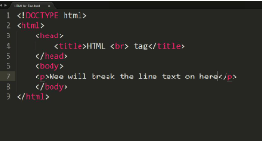

HTML Text Formatting-

* In HTML, you can apply various text formatting and styling using a combination of HTML tags and CSS (Cascading Style Sheets). Here are some common techniques for text formatting in HTML:
* Headings: Use heading tags (**<h1>** to **<h6>**) to create different levels of headings. Headings provide hierarchical structure and visual emphasis to your text.
* Paragraphs: Use the **<p>** tag to create paragraphs. Paragraphs are block-level elements that automatically create line breaks and add spacing around the text.
* Bold and Italic: Use the **<strong>** or **<b>** tags to make text bold, and the **<em>** or **<i>** tags to italicize text. These tags provide semantic meaning to your text and also affect its visual appearance.
* Underline: Use the **<u>** tag to underline text. However, it is recommended to use CSS to style text with underlines (**text-decoration: underline;**) rather than using the **<u>** tag for semantic purposes.
* Strikethrough: Use the **<s>** or **<del>** tags to create strikethrough text. These tags indicate that the text has been deleted or is no longer valid.
* Subscript and Superscript: Use the **<sub>** tag for subscript text and the **<sup>** tag for superscript text. These are commonly used for mathematical and scientific notations.
* Inline Code: Use the **<code>** tag to represent inline code or program code snippets within your text. It typically preserves the monospaced font style.
* Blockquote: Use the **<blockquote>** tag to create block-level quotations. It indents the text and visually separates it from the surrounding content.
* Remember that HTML tags provide structure and semantic meaning to your content, while CSS is used for styling and presentation. You can use CSS properties like font-family,
* 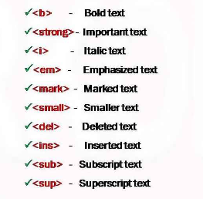
* Top of Form

HTML Blocklevel Element

* In HTML, block-level elements are those that create a block-level box on the web page. These elements typically start on a new line and occupy the full available width of their parent container. Some common examples of block-level elements include <div>, <p>, <h1> to <h6>, <ul>, <ol>, <li>, <table>, and others.
* Block-level elements are often used to structure and organize content on a webpage. They can contain other block-level and inline elements within them.
* Here's an example of how a block-level element, such as a <div>, could be used in HTML:
* html
* Copy code
* <div>
* <h1>Welcome to my webpage!</h1>
* <p>This is a paragraph of text.</p>
* <ul>
* <li>List item 1</li>
* <li>List item 2</li>
* <li>List item 3</li>
* </ul>
* </div>
* In this example, the <div> element acts as a container that holds the heading, paragraph, and unordered list elements. Each of these elements will be displayed as a block, starting on a new line and stretching across the entire width of the <div> container.
* If you were referring to something else or have additional questions, please provide more details, and I'll be happy to assist you further.

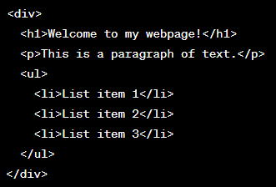

Html 5 images-

* In HTML5, you can display images on a webpage using the <img> element. The <img> element is a self-closing tag that does not require a closing tag.
* Here's the basic syntax for using the <img> element:
* html
* Copy code
* <img src="image-url" alt="alternative-text">
* <img src="path/to/image.jpg" alt="A beautiful landscape" width="500" height="300">
* Let's break down the attributes used in the example:
* src: This attribute specifies the source URL of the image. It can be a relative or absolute URL to the image file.
* alt: This attribute provides alternative text for the image. It is displayed if the image fails to load or if someone is using a screen reader to access the webpage.
* Here's an example of how you can use the <img> element to display an image on a webpage:
* html
* Copy code
* <!DOCTYPE html>
* <html>
* <head>
* <title>Image Example</title>
* </head>
* <body>
* <h1>My Image</h1>
* <img src="path/to/image.jpg" alt="A beautiful landscape">
* </body>
* </html>
* In the example above, the image file "image.jpg" is located in the "path/to" directory relative to the HTML file. The alternative text "A beautiful landscape" will be displayed if the image cannot be loaded.
* Remember to replace "path/to/image.jpg" with the actual path or URL to your desired image.
* You can also include additional attributes in the <img> element to control the image's size, alignment, and other properties. For example, the width and height attributes can be used to specify the dimensions of the image in pixels.

html

Copy code

<img src="path/to/image.jpg" alt="A beautiful landscape" width="500" height="300">

I hope this helps you understand how to use images in HTML5. If you have any further questions, feel free to ask!

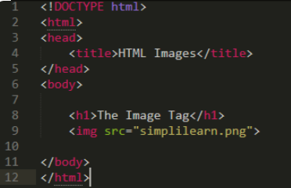

HTML Table-

<!DOCTYPE html>

<html>

<head>

<title>Table Example</title>

</head>

<body>

<table>

<tr>

<th>Header 1</th>

<th>Header 2</th>

<th>Header 3</th>

</tr>

<tr>

<td>Data 1</td>

<td>Data 2</td>

<td>Data 3</td>

</tr>

<tr>

<td>Data 4</td>

<td>Data 5</td>

<td>Data 6</td>

</tr>

</table>

</body>

</html>

In HTML5, you can create tables to organize and display tabular data using the **<table>**, **<tr>**, **<th>**, and **<td>** elements, among others. Here's an example of how to create a basic table structure:

htmlCopy code

* <!DOCTYPE html> <html> <head> <title>Table Example</title> </head> <body> <table> <tr> <th>Header 1</th> <th>Header 2</th> <th>Header 3</th> </tr> <tr> <td>Data 1</td> <td>Data 2</td> <td>Data 3</td> </tr> <tr> <td>Data 4</td> <td>Data 5</td> <td>Data 6</td> </tr> </table> </body> </html>
* Let's break down the table structure:
* The **<table>** element represents the table itself.
* Each row in the table is created using the **<tr>** element (short for "table row").
* The table headers are defined using the **<th>** element (short for "table header").
* The table data cells are created with the **<td>** element (short for "table data").
* In the example above, the table has a header row with three columns (Header 1, Header 2, and Header 3), and two data rows with corresponding data cells.
* You can add more rows and cells as needed by repeating the **<tr>**, **<th>**, and **<td>** elements. Additionally, you can style the table using CSS or apply attributes to the elements to control various aspects like cell alignment, borders, and more.
* This is just a basic example to get you started with HTML5 tables. If you have any specific requirements or further questions, please let me know!
* Top of Form
* Bottom of Form

HTML List-

* In HTML5, you can create lists using the **<ul>**, **<ol>**, and **<li>** elements. These elements allow you to display items in an unordered list or an ordered list. Here's an example of how to create both types of lists:
* Unordered List (**<ul>**):
* htmlCopy code

<ul>

<li>Item 1</li>

<li>Item 2</li>

<li>Item 3</li>

</ul>

<ul>

<li>Item 1</li>

<li>Item 2</li>

<li>Item 3</li>

</ul>

* In this example, the **<ul>** element represents the unordered list. Each list item is represented by the **<li>** element. The browser will typically display an unordered list with bullet points.
* Ordered List (**<ol>**):
* htmlCopy code
* <ol> <li>First item</li> <li>Second item</li> <li>Third item</li> </ol>
* In this example, the **<ol>** element represents the ordered list. The list items are again represented by the **<li>** element. The browser will display an ordered list with numbers or other symbols indicating the order of the items.
* You can nest lists inside other lists to create hierarchical structures. For example:
* htmlCopy code
* <ol>
* <li>First item</li>
* <li>Second item </li>
* <li>Nested item 1</li>
* <li>Nested item 2</li>
* </ol>

* In this example, an ordered list contains a second list (unordered) as a nested list item.
* You can also apply CSS styles or attributes to customize the appearance of the lists, such as changing the bullet points or numbering style, adjusting spacing, and more.
* I hope this helps you understand how to create lists in HTML5. If you have any further questions, feel free to ask!
* Top of Form

<ol>

<li>First item</li>

<li>Second item

<ul>

<li>Nested item 1</li>

<li>Nested item 2</li>

</ul>

</li>

<li>Third item</li>

</ol>

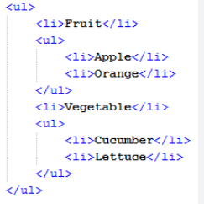

HTML Description List-

* In HTML, you can use the **<dl>**, **<dt>**, and **<dd>** elements to create a description list. The description list is used to display a list of terms and their corresponding descriptions. Here's how you can structure it:

<dl>

<dt>Term 1</dt>

<dd>Description 1</dd>

<dt>Term 2</dt>

<dd>Description 2</dd>

<!-- Add more terms and descriptions as needed -->

</dl>

* <dl> <dt>Term 1</dt> <dd>Description 1</dd> <dt>Term 2</dt> <dd>Description 2</dd> <!-- Add more terms and descriptions as needed --> </dl>
* Let's break down the elements used in the example:
* <dl>: This is the container element for the description list.
* <dt>: This represents the term or name being described. It should be placed inside the **<dl>** element.
* <dd>: This represents the description or definition of the term. It should be placed immediately after the corresponding **<dt>** element.
* You can have multiple **<dt>** and **<dd>** pairs within a single **<dl>** element to create a list with multiple terms and descriptions. The order of the **<dt>** and **<dd>** elements is important, as it determines the visual arrangement of the terms and descriptions.
* Styling can be applied to the description list using CSS to control its appearance, such as changing the font, size, color, or adding margins and padding.
* Top of Form

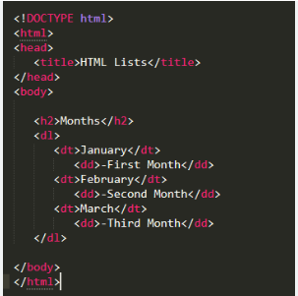

HTML in java script-

* If you're looking to generate HTML dynamically using JavaScript, you can manipulate the DOM (Document Object Model) using JavaScript to create and modify HTML elements. Here's an example of how you can create HTML elements and append them to the document using JavaScript:

<!DOCTYPE html>

<html>

<head>

<title>HTML Generation with JavaScript</title>

<script>

// JavaScript code to generate HTML

function generateHTML() {

// Create a new paragraph element

var paragraph = document.createElement("p");

// Create a new text node

var text = document.createTextNode("This is a dynamically generated paragraph.");

// Append the text node to the paragraph element

paragraph.appendChild(text);

// Get the body element

var body = document.getElementsByTagName("body")[0];

// Append the paragraph element to the body

body.appendChild(paragraph);

}

</script>

</head>

<body>

<h1>HTML Generation with JavaScript</h1>

<button onclick="generateHTML()">Generate HTML</button>

</body>

</html>

* In the example above, we have an HTML document with a **<script>** element containing a JavaScript function called **generateHTML()**. This function creates a new **<p>** (paragraph) element using **document.createElement("p")**. It then creates a text node with the content "This is a dynamically generated paragraph" using **document.createTextNode()**. The text node is appended to the paragraph element using **paragraph.appendChild(text)**. Finally, the paragraph element is appended to the **<body>** element using **body.appendChild(paragraph)**.
* When you click the "Generate HTML" button, the **generateHTML()** function is called, and a new paragraph is added to the document.
* This is a simple example, but you can use JavaScript to create and modify any HTML element, apply styles, add event listeners, and perform more complex operations on the DOM to dynamically generate and manipulate HTML content.
* Top of Form

HTML Java Script Example-

* Certainly! Here's an example that demonstrates how you can use JavaScript to manipulate HTML elements dynamically:
* <!DOCTYPE html>
* <html>
* <head>
* <title>HTML JavaScript Example</title>
* <script>
* function changeText() {
* // Get the paragraph element by its ID
* var paragraph = document.getElementById("myParagraph");
* // Change the text content of the paragraph
* paragraph.textContent = "New text!";
* // Change the background color of the paragraph
* paragraph.style.backgroundColor = "yellow";
* // Change the font size of the paragraph
* paragraph.style.fontSize = "20px";
* }
* </script>
* </head>
* <body>
* <h1>HTML JavaScript Example</h1>
* <p id="myParagraph">Original text.</p>
* <button onclick="changeText()">Change Text</button>
* </body>
* </html>
* In this example, we have an HTML document with a **<script>** element that contains a JavaScript function called **changeText()**. The function is triggered when the "Change Text" button is clicked.
* Inside the **changeText()** function, we retrieve the paragraph element using **document.getElementById("myParagraph")**. We then modify the text content of the paragraph using **paragraph.textContent**, change the background color using **paragraph.style.backgroundColor**, and adjust the font size using **paragraph.style.fontSize**.
* When you click the "Change Text" button, the **changeText()** function is called, and the specified modifications are applied to the paragraph element.
* This example demonstrates how JavaScript can be used to manipulate various properties and styles of HTML elements. You can apply similar techniques to create, delete, or modify other elements, add event listeners, handle user input, make AJAX requests, and perform numerous other dynamic interactions within your web page.
* Top of Form

HTML From-

<!DOCTYPE html>

<html>

<head>

<title>HTML Form Example</title>

</head>

<body>

<h1>HTML Form Example</h1>

<form action="submit.php" method="POST">

<label for="name">Name:</label>

<input type="text" id="name" name="name" required>

<label for="email">Email:</label>

<input type="email" id="email" name="email" required>

<label for="password">Password:</label>

<input type="password" id="password" name="password" required>

<label for="message">Message:</label>

<textarea id="message" name="message" rows="4" cols="30"></textarea>

<label for="gender">Gender:</label>

<select id="gender" name="gender">

<option value="male">Male</option>

<option value="female">Female</option>

<option value="other">Other</option>

</select>

<label for="newsletter">Subscribe to newsletter:</label>

<input type="checkbox" id="newsletter" name="newsletter" checked>

<input type="submit" value="Submit">

</form>

</body>

</html>

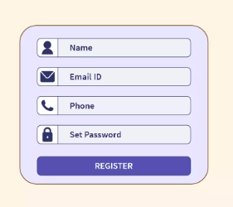

Html input type-

* HTML provides various input types that allow users to enter different types of data. Here are some commonly used input types in HTML:
* **text**: Creates a single-line text input field.
* **<input type="text" name="username">**
* **password**: Displays an obfuscated text input field for passwords.
* **<input type="password" name="password">**
* **email**: Validates that the input is an email address.
* **<input type="email" name="email">**
* **number**: Accepts numeric input. You can use **min** and **max** attributes to define a range, and **step** to specify the increment value.
* **<input type="number" name="age" min="0" max="100" step="1">**
* **date**: Allows the selection of a date. Some browsers may display a date picker for easier selection.
* **<input type="date" name="birthdate">**
* **checkbox**: Represents a checkbox for selecting one or more options.
* **<input type="checkbox" name="newsletter" value="true">**
* **radio**: Represents a set of radio buttons where only one option can be selected.
* **<input type="radio" name="gender" value="male"> Male**
* **<input type="radio" name="gender" value="female"> Female**
* **file**:
* **<input type="file" name="avatar">**
* **submit**: Creates a submit button to submit the form.
* **<input type="submit" value="Submit">**
* **reset**: Creates a button to reset the form fields to their default values.
* **<input type="reset" value="Reset">**
* These are just a few examples of the available input types in HTML. Each input type has its own specific purpose and behavior, allowing you to collect different types of data from users. You can combine these input types with additional attributes to further customize their behavior and validation.

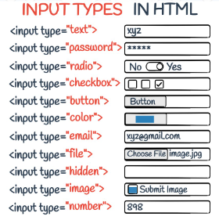Top of Form